Telegram BlackBox Setup

# Getting Credentials

## What Do I Need Telegram ?

The **BlackBox** sends alert notifications to you when it senses either a vibration or when an external sensor is triggered. To do this the BlackBox needs a means in order to accomplish this. Telegram is able to do this and many other things including being a secure messenger - its main purpose. So if you already have Telegram installed you are ready to follow this guide. If you do not yet have Telegram [go here for all things Telegram](https://telegram.org).

Once installed **Telegram** is ready to work as a messenger but we need to get two things to make it work with the BlackBox. And that is the **Bot Token** and the **Chat ID**.

Telegram Messenger  
Get Your Bot Token

# Bot Token

## What Is The Bot Token ?

The **Telegram Bot Token** is a unique string of characters that authenticates your BlackBox with Telegram. It is a secret token that should be kept secure and not shared with anyone who does not need direct access to the BlackBox.

In simple terms, it’s like a password that allows your BlackBox to communicate with Telegram servers and send messages.

# Get Your Bot Token With The BotFather

## Who Is The “BotFather” ?

## 

**@BotFather** is a Telegram bot that allows you to create and manage other bots on the Telegram app. It is the first bot that you should contact to create a new bot on Telegram.

Here is the direct link to open the BotFather <https://t.me/BotFather>

You can issue the /newbot command to create a new bot and follow the instructions provided by @BotFather.

For use with the **BlackBox** we really just need the bot token from the BotFather. Any other configuration such as a profile picture and creating commands for the bot is not needed. If you feel you are proficient enough to want to make custom changes, go ahead but it’s optional.

# On To The Chat ID

Once you have your bot token copy it to someplace we can use it after the next step which is getting your **Chat ID**.

Telegram Messenger  
Get Your Chat ID

# Chat ID

## What Is The Chat ID ?

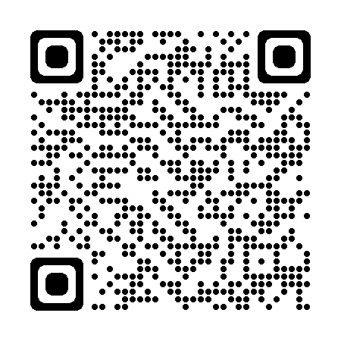

The **Telegram Chat ID** is basically your id on the Telegram network, not to be confused with your username. And unlike the username the chat id is a little bit harder to see but not hard to get.

Much the same as the BotFather there is a link to get your chat id. Simply follow the instructions and your unique chat id will be shown.

Here is the direct link to open the IDBot <https://t.me/myidbot>

# On To The Next Step

Once you have your **Chat ID, save** it where you saved the **Bot Token**. And now that we have both the token and chat id we can now use them to connect to the **BlackBox**.

Refer to the next steps in the **BlackBox Connection Guide** listed at <https://github.com/KaiKai7/BlackBox>. You can download either the pdf or doc file.